Mr SGs Momentum & forces notes
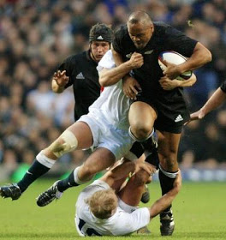

Momentum

-When people use the word momentum conversationally, they are generally describing how much force is required to stop a moving object

-An object that is heavier or travelling faster is harder to stop than a lighter or slower object

-An object’s momentum is equal to the product of its mass and its velocity

p = m v where p is momentum (kg m s⁻¹), m is mass (kg) and v is velocity (m s⁻¹)

-As the product of two vectors, momentum is also a vector quantity

-As we will only be considering momentum in a single dimension, a sign convention of + and – is used for changes in momentum

Conservation of momentum

-In any collision between objects, momentum is conserved

-The sum of momentum before the collision is equal to the sum of momentum after the collision

-This is called the ‘law of conservation of momentum’

∑p_{before} = ∑p_{after} or ∑mv_{before} = ∑mv_{after}

-Problems involving 1D conservation of momentum can be solved by applying a +/- sign convention to the directions involved an solving the problem algebraically

-For two objects colliding in one dimension, the equation can be stated as:

m₁u₁ + m₂u₂ = m₁v₁ + m₂v₂ where m₁ and m₂ are the masses of objects 1 and 2 (kg), u₁ and u₂ are the initial velocities of the two objects and v₁ and v₂ are the final velocities (m s⁻¹)

Proving the law of conservation of momentum (E)

-Newton’s third law states than when two objects collide, the force exerted by the first object on the second is equal in magnitude and opposite in direction to the force exerted by the second object on the first

-If a sign convention is used to indicate direction, the law can be stated mathematically as follows:

F₁ = -F₂

-Newton’s second law states that force is equal to the product of mass and acceleration, so:

m₁a₁ = -m₂a₂

-As acceleration is equal to change in velocity divided by time:

m₁(v₁ – u₁) = -m₂(v₂ – u₂)
t t

-As the time for the collision is equal for both objects, this can be simplified to:

m₁(v₁ – u₁) = -m₂(v₂ – u₂)

-Multiplying out the brackets gives:

m₁v₁ – m₁u₁ = -m₂v₂ + m₂u₂

-Which can be rearranged to give the law of conservation of momentum

m₁u₁ + m₂u₂ = m₁v₁ + m₂v₂

Equations for conservation of momentum

-The law of conservation of momentum can be expressed in slightly different ways, depending on the type of collision and the number of objects involved

-When two objects combine to form a third object, it can be written as:

m₁u₁ + m₂u₂ = m₃v₃

-In “explosive collisions”, where one object breaks up into two smaller objects, it is written as:

m₁u₁ = m₂v₂ + m₃v₃
Change in momentum (impulse)

-While total momentum is conserved in a collision, the momentum of any single object can change

-A collision can cause an object to change its velocity, either by changing its speed or its direction

-As p = mv, any change in velocity will cause a change in momentum

-Change in momentum (Δp) is known as impulse (I) and has units of kg m s ⁻¹

Impulse in one dimension

-Impulse in one dimension is calculated using the formula:

I = Δp = p_{final} – p_{initial} = mv – mu

where I is impulse (kg m s⁻¹), Δp and p are change in momentum and momentum (kg m s⁻¹), m is mass (kg) and v and u are final and initial velocity (m s⁻¹)

Impulse in two dimensions

-When an object changes its direction, this causes a change in its velocity and its momentum

I = mv – mu = m(v – u) = mΔv

-For impulse in two dimensions, the direction cannot be shown with a sign convention, so a bearing must be provided

-The change in velocity (Δv) needs to be calculated using vector subtraction by geometry

-These is done by adding together the vectors v and -u

-Pythagorus’ theorem is used to calculate the magnitude of Δv and trigonometry is used to calculate its direction

-The value for impulse can be calculated by multiplying m by Δv, with the direction for impulse the same as the direction for Δv

Newton’s Laws
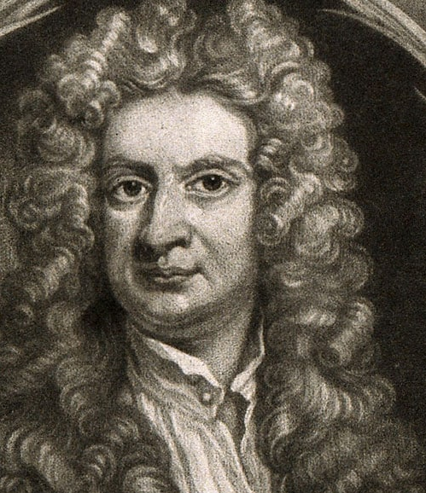

-Isaac Newton (1643-1727) was an English physicist and mathematician and one of the most influential scientists in human history

-His publications laid the foundation for classical mechanics (the study of motion) and he was also hugely important in the development of calculus and our understanding of optics and gravity

-Newton’s laws of motion relate to the action of forces and the motion of objects

Forces

-In simple terms, a force is defined as a push, a pull, or a twist

-While you cannot directly see a force, it can be recognised by its effect

-A force is anything that can act to change the speed, direction or shape of an object

-Contact forces are those that act directly on an object (e.g. a cricket bat striking a ball)

-Non-contact forces are those that act at a distance (e.g. gravity, electrical/magnetic forces)

-The SI unit for force is the Newton (N), named after Sir Isaac Newton

-A net force of 1 N acting on a mass of 1 kg produces an acceleration of 1 ms⁻²

-Forces are vectors, so need to be given with a direction, either using a sign convention (1D) or a bearing (2D)

-When multiple forces are acting on an object, the object will behave as if a single force equal to the sum of the other forces (net force) was acting on it

-Net force (F_{net}) can be calculated using vector addition in one or two dimensions:

F_{net} = F₁ + F₂ + F₃ + …… + F_{n}

Newton's first law

-Isaac Newton’s first law is sometimes called the law of inertia:

“Every object continues in its state of rest or of uniform velocity
in a straight line, unless acted on by a net external force.”

-When you push a pencil across the desk, it eventually stops moving because of the force of friction acting on the opposite direction to the pushing force

-Without this friction, it would continue moving until it collided with another object

-Whenever an object is accelerating or decelerating, it must be because a net external force is acting on the object

-This idea counteracted earlier views that an objects natural state was at rest and that a force was needed to keep an object in motion

-This tendency of an object to maintain its state of rest or motion is known as inertia

-The larger an objects mass, the greater its inertia

Inertial reference frames (E)

-Whenever we describe the motion of an object, the description will be relative to a frame of reference

-At a Year 11 level, it is generally assumed that the earth’s surface is the frame of reference, unless stated otherwise

-Newton’s first law does not to hold in accelerating reference frames

-In the reference frame of an accelerating car, a cup resting on the dashboard will start accelerating towards the driver, even though no force has acted on the cup

-Reference frames in which Newton’s first law holds are called inertial reference frames

-Most of the time it can be assumed that a reference frame that is fixed on the earth is an inertial reference frame

-Reference frames in which Newton’s first law does not hold are called non-inertial reference frames

Newton's second law

-While Isaac Newton’s first law describes how an object will maintain its motion in the absence of a net force acting on it, his second law explains how it will respond when acted upon by a net force

-This law describes the mathematical relationship between the magnitude of the net force acting on an object, the mass of the object and the acceleration caused by the force:

“The acceleration of an object is directly proportional to the net force
acting on it and inversely proportional to the object’s mass”

-This law is often written mathematically as:

F_{net} = m a where F_{net} is net force (N), m is mass (kg)
and a is acceleration (ms⁻²)

-Newton’s law explains why an object with a lower mass will experience a greater acceleration than a heavier object when acted upon by a force of similar magnitude (e.g. why motorcycles are typically capable of a greater acceleration than cars)

-It is important to note that the product of mass and acceleration gives the net force acting on an object; any individual force may have a higher or lower magnitude

Newton's third law
-When a hammer used to push in a nail, the hammer exerts a downward force of the nail

-As the hammer hits the head the head of the nail it abruptly decelerates (accelerates in the upwards direction)

-Newton’s first law tells us that an object will only experience acceleration if it is acted on by a net force

-The only way that the hammer could experience such a deceleration is if the nail exerts an upward force on the hammer at the same time the hammer exerts a downward

-Newton’s third law describes the relationship between these action and reaction forces:

”Whenever one object exerts a force on a second object, the second
object exerts an equal force in the opposite direction on the first.”

-This is often stated as: for every action (force) there is an equal and opposite reaction (force)
Identifying action & reaction forces
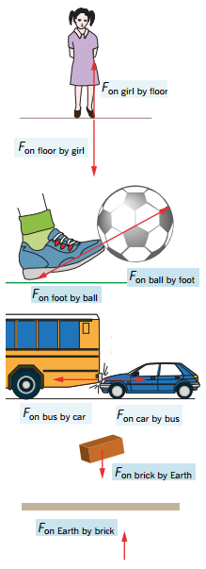

-When identifying the reaction force for a particular action force, it can be helpful to label the force as follows:

F_{on x by y} where: x: “object the force is acting on”
y: “object applying the force”

-Note that while the magnitude of the action and reaction forces is identical, they will not cause the same acceleration due to the different masses of the objects they act on

e.g. for a 1.00 kg brick being attracted to the earth by its gravity:

Let upwards be positive and downwards be negative

F_{on Earth by brick} = - F_{on brick by Earth} = 9.80 N

a_{brick} = F_{on brick by Earth} / m_{brick} = -9.80 / 1.00 = -9.8 m s⁻²

a_{Earth} = F_{on Earth by brick} / m_{Earth} = 9.80 / (5.97 x 10²⁴) = 1.65 x 10⁻²⁴ m s⁻²

Weight and normal forces
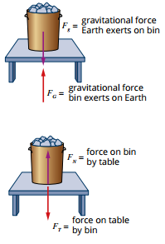

-When an object is falling in mid-air, an unbalanced force is acting on it, causing it to accelerate towards the ground

-This is the weight force (F_{g} or F_{w}), the force due to gravity

F_{g} = mg

(where F_{g} is weight force (N), m is mass of the object (kg) and g is gravitational acceleration (9.80 m s⁻² at the Earth’s surface)

-When an object is placed on the ground, it still experiences the weight force, but it is no longer accelerating so the weight force must be being balanced

-In the diagram above, you can see how gravity pulling down on the bin, causes it to exert a force on the table (F_{bin on table}) that is equal to the weight force experienced by the bin (F_{g})

-Newton’s third law, tells us that this force will be opposed by a reaction force (F_{table on bin})

-This contact reaction force provided by a surface that is perpendicular to another surface is called the normal reaction force
-This is often abbreviated to the normal (F_{N})

-The normal force provided by a surface will always be equal in magnitude and opposite in direction to the weight force (F_{g}), they are technically not an action/reaction force pair, as they are both acting on the same object

Forces & Impulse

-We have already seen that impulse (change in momentum) can be calculated using the formulae:

I = Δp = mv – mu = m (v – u) = mΔv

-The formula for acceleration can be rearranged to solve for Δv:

a = Δv , so Δv = aΔt
Δt

-When this is substituted into the first equation, it gives:

I = maΔt

-The formula for force (F_{net} = ma) can be substituted into this equation to give:

I = F_{net} Δt

-As impulse is the product of F and Δt, it can be given with units of N s (1 N s = 1 kg ms⁻¹)

Force & time

-This formula shows that for a given change in momentum, the product of the force experienced and time for the momentum change is constant

-This means that the force experienced will be larger, the shorter the time interval is

-Designers and engineers use this information in areas such as car safety

-A car with a given mass and travelling at given speed will always experience the same impulse in a collision that results in it coming to a complete stop

e.g. for a Toyota corolla with a mass of 1375 kg, travelling at 60 km h⁻¹
(16.7 ms⁻¹) that collides with a wall, coming to a complete stop:

I = m(v – u) = 1375 x (16.7 – 0) =22 900 kgms⁻¹ (3 sf)
-It is impossible to change the impulse for the collision without changing the cars mass or initial velocity


-Engineers and designers try to reduce the force experienced by the occupants of the car by increasing the time over which the collision occurs

-One way they do this is with crumple zones, areas of the car (other than the passenger compartment) that are designed to crumple in a collision to extend the time over which the impulse occurs

-Bicycle and motorcycle helmets work in the same way

-A layer of expanded polystyrene foam (EPS) compresses during a collision, increasing Δt and reducing the force experienced by the brain

-Likewise, this is why it hurts less to fall of a soft surface (e.g. grass instead of concrete)

-A soft surface will compress when you fall on it, increasing Δt and reducing F

Determining impulse from changing force

-In many collisions, the force applied is not constant

-While the total impulse can be calculated using; I = F_{av}ΔT

the force at any moment in time will not necessarily be equal to the average force

-It can be more useful to plot a force time graph for the collision

-The area under the curve will be equal to the product of force and time (e.g. impulse)
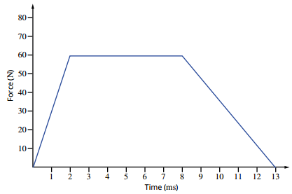
I = F_{av}Δt = area under a F-t graph

e.g. for the graph to the right:

I = area
= (½ x 2 x 10⁻³ x 60) + (6 x 10⁻³ x 60) + (½ x 5 x 10⁻³ x 60)
= 0.570 kg ms⁻¹

Mass & Weight

-While the terms mass and weight are often used interchangeably, in Physics they have different meanings

Mass

-Mass is a scalar quantity, related to the amount of matter present in a substance

-While it is impossible to directly measure the matter contained in something, mass can also be defined by the relationship between force and acceleration

-The mass of an object determines how much acceleration it will experience when acted upon by a force of a given magnitude:
m = F
a

-Due to this, mass can be can defined as the property of a body that resists a change in motion caused by a force (e.g. a measure of its inertia)

-The mass of an object is not affected by the strength of a gravitational field

-Applying a 1 N net force to a 1 kg mass will result in a 1 ms⁻² acceleration, regardless of whether it is applied of the Earth (g_{Earth} = 9.8 ms⁻²) or the moon (g_{moon} = 1.62 ms⁻²)

Weight

-An objects weight is the force on the object due to a gravitational field

-It is given the symbol F_{g} and can be calculated using the formula:

F_{g} = mg

(where F_{g} is weight force (N), m is mass of the object (kg) and
g is gravitational acceleration (9.80 m s⁻² at the Earth’s surface)

-Force is a vector quantity, so it has a direction (generally provided using a sign convention)

-Because the strength of a gravitational field depends on the mass of the object, the value for gravitational acceleration will be different on different planets

-This means that an object will have different weight on the Earth than it will on the moon, even though they have the same mass

Work & Energy

-Work and energy are very closely related concepts in Physics

-Work is performed whenever a force is applied to an object causing it to change

-Energy represents the ability to perform work

-Kinetic energy is energy due to the motion (e.g. a moving truck will cause an object to change position if they collide)

-Potential energy is due to an object’s position relative to other objects or to a field (e.g. a ball at the top of a hill will change position if it is released)

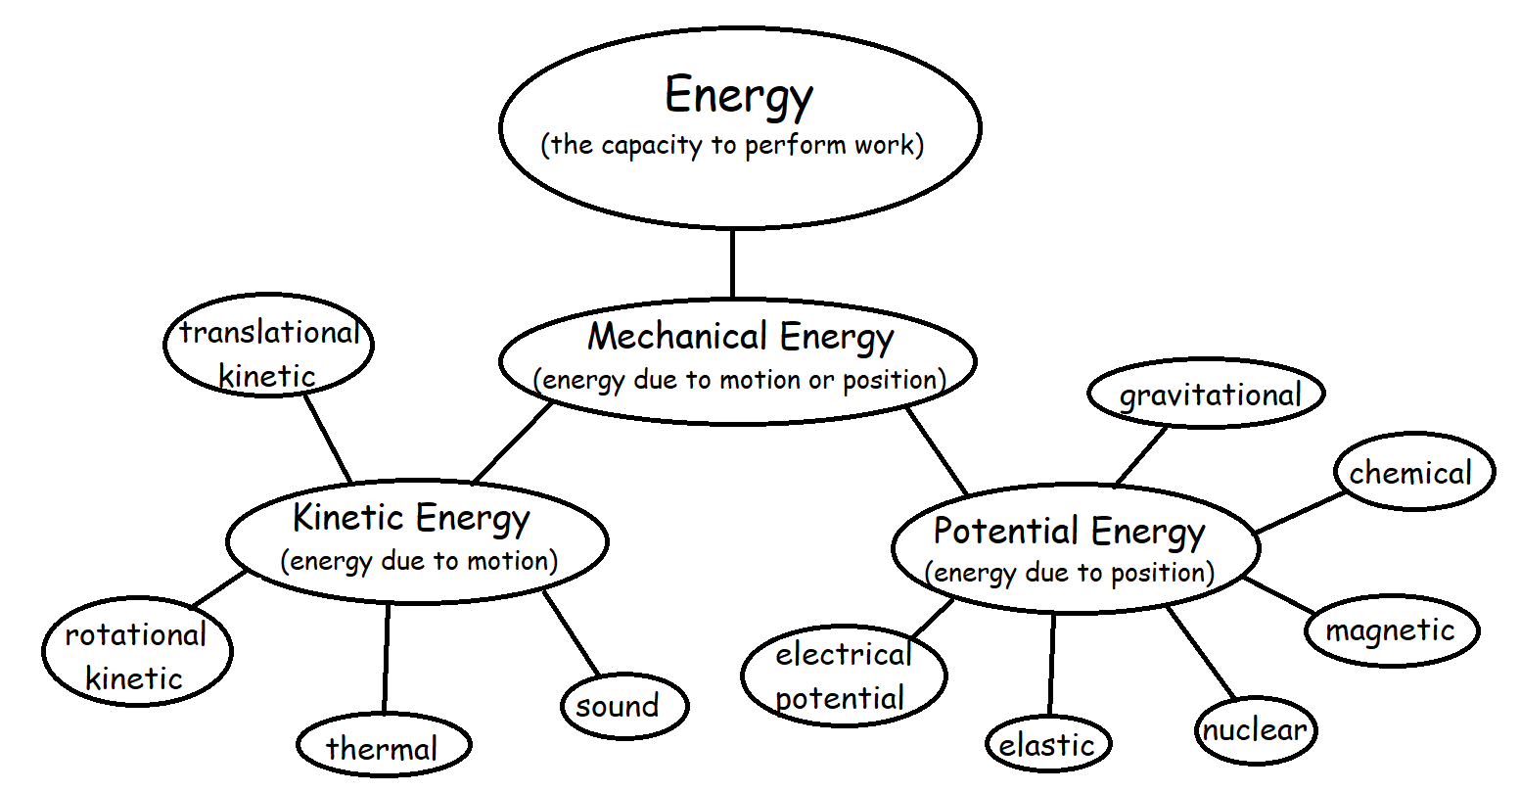

Work

-Work is done whenever an unbalanced force is applied to an object, causing it to change position

-The amount of work done is determined by the magnitude of the force and the distance the object moves in the direction of the force (displacement)

W = F x s (W = work done (J), F = force applied (N), s = displacement (m))

-Work done is measured in Joules, where 1 Joule is defined as the work done when a force of 1N moves an object a distance of 1m in the direction of the force

-Work can also be defined in relation to a change in energy:

W = ΔE (where W = work done (J), ΔE = change in energy (J))
Calculating work performed

-Work is the product of force and displacement

-If an applied force does not cause a change in displacement, no work is performed

-While it is normally easy to measure an objects displacement, it can be difficult to determine the force that caused the work to be performed

Calculating the force responsible for work

-An object will often have multiple forces acting on it

-Only the component of the net force that causes the object to become displace is used to calculate the work performed

-When an object is displaced vertically, the force applied to produce the work is the force to overcome gravity

W = Fs = F_{g}s = mgs = mgh (F_{g} = weight (N), m = mass (kg) h = height (m))

-When an object is displaced horizontally, the force that causes the displacement is the force applied to overcome friction

W = Fs = F_{f}s (F_{f} = frictional force (N))

-When a force is applied at an angle to the displacement, only the component of the force acting in the plane of displacement contributes to the work performed
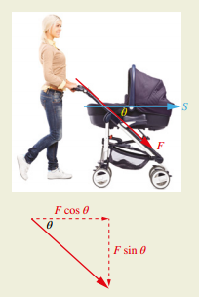

-The component of the force that is acting in the plane of the displacement (parallel to the displacement) can be calculated by:

F|| = F cosθ

Where F|| is the parallel component of the force (N), F is the force (N) and θ is the angle between the application of the force and the plane of the displacement (º))

-The work performed when the force is not applied along the plane of displacement can be calculated by:

W = F|| s = Fs cosθ

Force-displacement graphs
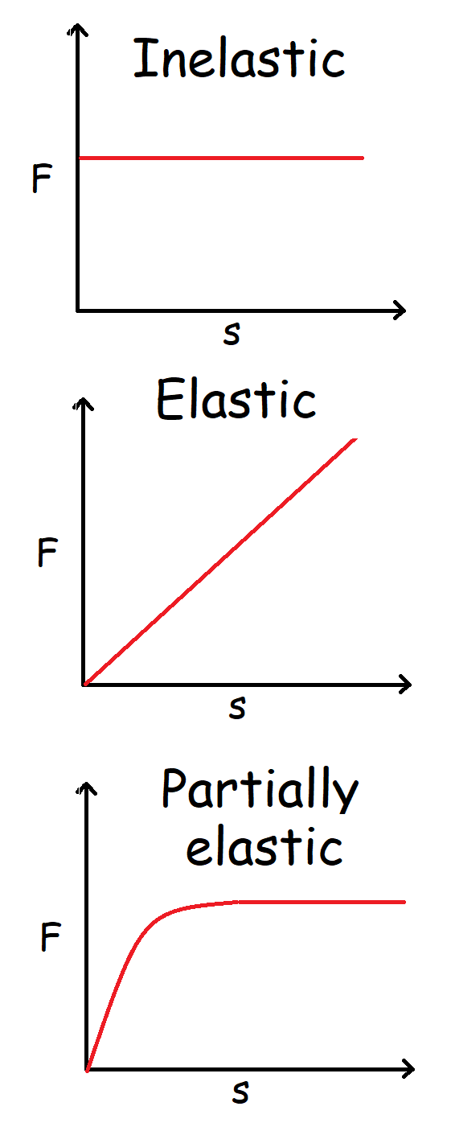

-When performing work on many objects, the force does not change as displacement increases

-As a 2 kg box is lifted, the same force (F_{g} = mg = 2 x 9.8 = 19.6 N) at all points in its motion

-For elastic objects like springs, the more the spring is stretched, the more force is required to further stretch it (e.g. F increases with displacement)

-For objects where force does not remain constant with increasing displacement, it is often useful to plot a force-displacement graph (also called force-extension graph)

-The work done to provide a give displacement can be calculated by taking the area under the force-displacement curve

-Where the line is a complex shape, the area under the curve can be estimated by counting squares

Kinetic Energy

-Kinetic energy is energy that an object possesses due to its motion

-The energy an object possesses due to its velocity will be equal to the work that was performed to accelerate the object to that velocity (as W = ΔE)

Deriving the kinetic energy equation (E)

-One of our earlier equations of motion
(v² = u² + 2as) can be rearranged to calculate a = v²-u²
the acceleration required to accelerate an 2s
object to its final velocity in a given displacement

-This expression can be substituted into our F = m v²-u²
equation for the force required to produce this 2s
acceleration (F = ma) to give:

-This expression for force can be substituted W = m v²-u² s
into the work equation (W = Fs) to give: 2s

-Which simplifies to give: W = ½ mv² – ½ mu²

-For an object that started from rest, u = 0, so
the equation to calculate the work performed W = ΔE = E_{k} = ½ mv²
(and hence kinetic energy gained) when an object
is accelerated to a given velocity becomes:

Performing calculations involving kinetic energy

-While you are not expected to derive the kinetic energy equation, you should be able to use it to calculate an objects kinetic energy:

E_{k} = ½ mv²

-You should also be able to use the work-energy theorem to calculate the work performed when an object changes velocity:

W = ½ mv² – ½ mu² = (E_{k})_{final} – (E_{k})_{initial} = ΔE_{k}

Elastic and Inelastic Collisions

-While momentum is always conserved in collisions, kinetic energy can be lost as it transforms into other types of energy (heat, sound, etc.)

(Perfectly) Elastic Collisions: Collisions where kinetic energy is transferred between objects and no energy is transformed into heat/sound/deformation

e.g. E_{k}(before) = E_{k}(after)

Inelastic collisions: Collisions where kinetic energy is not conserved

-Perfectly elastic collisions do not exist in everyday situations, but collisions between atomic and subatomic particles can be considered perfectly elastic

Gravitational Potential Energy

-Gravitational potential energy (E_{p}) is the energy an object possesses due to its position in a gravitational field

-It can be calculated from the work required to lift an object against gravity

-The work performed when an object is lifted can be calculated from the force required to lift it (e.g. to overcome its weight force) and the object’s displacement (change in height):

W = F s = F_{w} Δh

-As F_{w} = m g, this can be rewritten as:

W = m g Δh

-The work-energy theorem tells us that the work performed on an object will be equal to the energy that object gains, so:

E_{p} = m g Δh (E_{p} = gravitational potential energy (J), g = gravitational
acceleration (9.8 m s⁻², Δh = change in height (m))

-When calculating gravitational potential energy, the height at which E_{p} = 0 needs to be defined

-This is normally given as ground level

Law of Conservation of Energy

-The law of conservation of energy is often stated as:

“The total energy of an isolated system in conserved” or

“Energy cannot be created or destroyed, only transformed from one form to another”

Mechanical Energy

-For an object moving in a gravitational field, mechanical energy is equal to the sum of its gravitational potential and kinetic energies:

E_{m} = E_{p} + E_{k} = mgΔh + ½ mv²

-Mechanical energy is conserved as an object moves up and down in a gravitational field

-If an object is thrown upwards, its kinetic energy will decrease as its gravitational potential energy increases

-If an object falls, its gravitational potential energy will decrease as its kinetic energy increases

-When an object is motionless at its highest position, it will have no kinetic energy and its gravitational potential energy will be equal to its mechanical energy

At h = max, E_{k} = 0 and E_{p} = E_{m}

-In the instant before an object hits the ground, it will have no gravitational potential energy and its kinetic energy will be equal to its mechanical energy

At h = 0, E_{p} = 0 and E_{k} = E_{m}

-For a falling object, its initial E_{p} will be equal to its final E_{k}, so:

E_{p}(initial) = E_{k}(final)

mgh = ½ mv²

v = √(2gh)

-If an objects mechanical energy can be calculated, these formulae can be used to calculate its kinetic and potential energies at all points of its motion
Loss of mechanical energy/ energy transformations

-In the real world, mechanical energy is not always concerned

-When a ball is dropped and allowed to bounce, it will not bounce all the way up to its initial height

-As the ball bounces, kinetic energy is transformed into elastic potential energy and back into kinetic energy as the ball deforms and springs back into shape

-While total energy is conserved during these transformations, mechanical energy is lost as it is transformed into other forms such as sound and heat when the ball bounces

Efficiency of energy transformations

-Whenever energy is transformed from one form to another, some useful energy is always “lost” due to undesirable transformations

-This is normally due to transformations that produce heat and sound energy

-The efficiency of a transformation can be calculated by:

Efficiency (η) = total energy transformed x 100 = energy output x100
total energy supplied energy input

Power

-Power is the rate at which work is done, or at which energy is transferred or transformed:

P = W = E (P = power (W), W = work (J),
t t E = energy (J) and t = time (s))

-Power has units of watts (W) where 1 W = 1 J s⁻¹

-In many situations, a force is provided to an object to keep it moving at a constant speed (e.g. a car’s engine providing the force needed to overcome air resistance and friction with the road)

-The power required to supply such as force can be calculated by substituting the formulae for work (W = Fs) and average velocity (v_{av} = s/t) into the power equation:

P = W = Fs = Fv_{av}
t t

